Software Requirements Specification

for

Mobile Phone Store Management System
Version 2.0
Prepared by Sarthak Oberoi, Anmol Arora, Vansh Kharyal
Table of Contents
Introduction 1
Purpose 1
Document Conventions 1
Intended Audience and Reading Suggestions 1
Project Scope 1
References Error! Bookmark not defined.
Overall Description 2
Product Perspective 2
Product Features 2
User Classes and Characteristics 2
Operating Environment 3
Design and Implementation Constraints 3
User Documentation 4
Assumptions and Dependencies Error! Bookmark not defined.
System Features 4
Staff Management 4
Inventory Management
Sales Management
Security 5
External Interface Requirements 6
User Interfaces 6
Hardware Interfaces Error! Bookmark not defined.
Software Interfaces Error! Bookmark not defined.
Communications Interfaces 6
Other Nonfunctional Requirements 6
Performance Requirements 6
Safety Requirements Error! Bookmark not defined.
Security Requirements 6
Software Quality Attributes 7
Other Requirements 7

Revision History

Introduction

Purpose
The Mobile Store Management System will be the revised version of the previous build which was made in the Minor Project I and hence its release number will be 2.

This SRS documentation will be covering the overall description of the product, listing its features, new changes from the previous build, requirements and other things that will help the reader to get the overview of the software application.

Document Conventions
This SRS is documented as per as the instructions and formats provided by our mentor.

Intended Audience and Reading Suggestions
This documentation is intended to be read by the developers, project managers, users, testers, and documentation writers. It is designed and organized in such a way that it tries to cover all the system features, characteristics, perspective, requirements and more which will help them to get an overview of the software before developing or using the software. However, this document will not provide the complete guidelines for the user as the software is still in development.

Project Scope
This project could be implemented in an average sized organization. An average company will not be very keen on spending loads of money on ledgers. Whereas this project will greatly reduce the costs which is using common and cheap office items like database and desktop application. And also, there is no requirement to store books or accounts. The data is directly stored in the database in the hard disk of the PC.

References
Previous year project report.
Mobile stores billing details. (Invoice of recently purchased devices)
Device details from shopping websites like flipkart, amazon etc.

Overall Description

Product Perspective
- The mobile store management system is a proposed replacement for the manual registration and billing of products sold in the store.
- This system will help in managing the inventory of the store, the staff and the invoice generation and history management.
- It will provide a user-friendly interface to the staff and the administrator of the store with various helpful features.

Product Features
The mobile store management system will provide the following features:

- Staff Management
- Inventory Management
- Sales Management
- Security Features

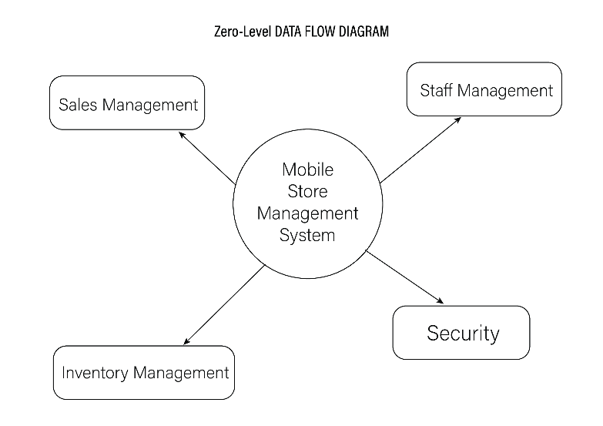
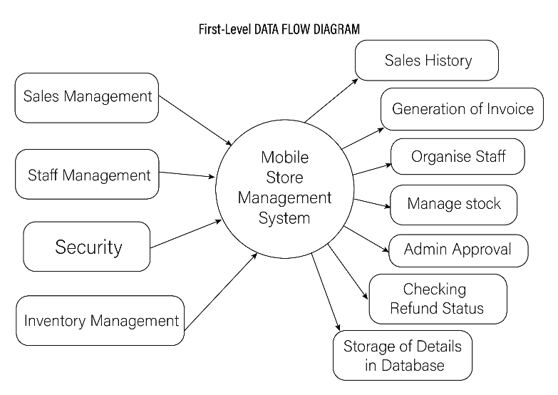
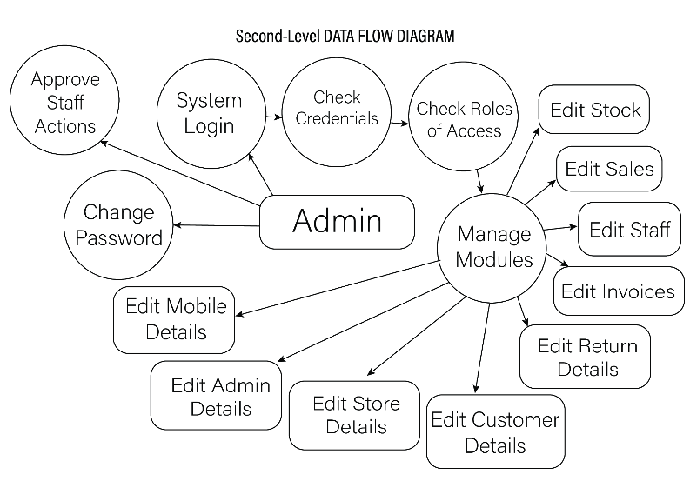

User Classes and Characteristics
There will be two user classes who will use this system:

- Administrator / Manager
- Administrator will be either the owner of the store or the manager of the store whose job will be to manage the staff members and keep a check on their sales.
- They will be able to login to the system using the common login portal. And can have access to staff management features plus the features which are provided to the staff.
- They will also able to view the statistics of sales and order histories along with the generated invoice of the purchases.

- Staff
- Staff will be common user of the system who has to use the application on a day-to-day basis.
- They will have access to the features like generating the invoice, managing the inventory, etc.
- The staff will be able to access these features after signing up on the system with valid details which needs to be approved by the administrator.

Operating Environment
- The product will be operating in windows environment.
- A Database software will be required to create new database and store and read relevant information.

Design and Implementation Constraints
<Describe any items or issues that will limit the options available to the developers. These might include: corporate or regulatory policies; hardware limitations (timing requirements, memory requirements); interfaces to other applications; specific technologies, tools, and databases to be used; parallel operations; language requirements; communications protocols; security considerations; design conventions or programming standards (for example, if the customer’s organization will be responsible for maintaining the delivered software).>

N/A

User Documentation
This project will include a user manual. The user manual will include Complete overview of the products, Configuration of the Tool used (SQL Server), technical details, backup procedures and Contact Details for any assistance.

Assumptions and Dependencies
<List any assumed factors (as opposed to known facts) that could affect the requirements stated in the SRS. These could include third-party or commercial components that you plan to use, issues around the development or operating environment, or constraints. The project could be affected if these assumptions are incorrect, are not shared, or change. Also identify any dependencies the project has on external factors, such as software components that you intend to reuse from another project, unless they are already documented elsewhere (for example, in the vision and scope document or the project plan).>

System Features

Security Features
3.1.1 Description and Priority
- The security feature is of high priority because the system needs to be prevented by unauthorized access.
- This will be done by password protecting the system by a login portal.
- User will have to create an account.
3.1.2 Stimulus/Response Sequences
- The user will need to open the system where they will be greeted with a welcome message and a login portal.
- The login portal will ask the users to either login or signup.
- Logging in with the id and password will take the user straight to the system be authorizing the password and checking if the account is of a staff member or administrator.
- For signing up, (which will only be available to the staff members as administrator account will be created by the software team.) the staff member will need to fill in all the relevant details which needs to be approved by the administrator and then grant access to the system to the staff member.

3.1.3 Functional Requirements
REQ-1: User must have a registered and approved account in order to access the system.

Staff Management
3.1.1 Description and Priority
- The staff management feature is one of the core features of this system.
- This system allows the staff to register themselves with the required details which helps the organization or the store to keep a track and record of the working staff.
- This will also allow the administrator to check the statistics.
3.1.2 Stimulus/Response Sequences
- The staff member will sign up using the necessary details and setting a password
- The details will then be sent to the administrator for the approval and after approval the staff will gain the access to the system where they will use those features to make sales and manage inventory.
- All their usage data will be recorded and shown to the administrator as statistics.
3.1.3 Functional Requirements
REQ-1: The staff will only be managed by the administrator.

Inventory Management
3.1.1 Description and Priority
- This feature will contain many sub features which allows the staff member to add, update, and manage the store’s inventory.
3.1.2 Stimulus/Response Sequences
- The staff member will have many options like add, update, delete, search etc. to perform on the inventory.
- All the features will be connected to the database system which will update according to the inputs given by the user.
3.1.3 Functional Requirements
REQ-1: User must be logged in to access these features.

Sales Management
3.1.1 Description and Priority
- This feature is related to the invoice generation and billing according to the inputs given by the staff member as per as the requirements of the customer.
- The generated bill will include the store details, details of the customer, and the details of the items the customer has purchased with the cost and taxes and total amount.
- The staff can also view the invoice history of the past sales with bill and other details.
- The administrator will be able to view all the invoices of all the staff with the statistics of sales by all the staff members.
3.1.2 Stimulus/Response Sequences
- The staff will select the new sale feature and select the items in the inventory.
- The system will show the number of items selected along with the price of those items.
- The staff will then select what they want to do with the selected items.
- On the selection of purchase and generate bill feature. The system will show the form to fill in the customer details. And then generate the bill.

3.1.3 Functional Requirements
REQ-1: User must have a registered and approved account in order to access this system feature.

External Interface Requirements

User Interfaces
The system will include several GUI Forms created using net beans – java IDE.

Hardware Interfaces
Processor: - Pentium 4 & Above
Hard disk Capacity: - 5 GB
RAM: - 512 MB

Software Interfaces
Any windows operating system which can run java projects
MYSQL Database software and connection tools

Communications Interfaces
MySQL database will be connected to it in the backend.

Other Nonfunctional Requirements

Performance Requirements
- 90% of the results shall be processed in less than one second.
- Data should be secured and backed up every quarter hour.
- Software should be operable 24 hours a day and accessible in real-time.
- Encryption will Enable Security

Safety Requirements
- The Database may get crashed or damaged due to some viruses or operating system requirements.
- Therefore, it is mandatory to have backup for your data. UPS / Inverter facility should be there in case of power failure.

Security Requirements
- Software will use secure Database
- Staff can just see the products & mark their attendance. They cannot edit or modify anything except their personal information.
- Proper Admin Authentication Will be provided.

Software Quality Attributes
- 90% of the results shall be processed in less than one second.
- Data should be secured and backed up every quarter hour.
- Software should be operable 24 hours a day and accessible in real-time.
- Encryption will Enable Security

Other Requirements
Domain requirements: -
- This Software must have basic functions: storing, tracking, updating (data or things that we keep in the store), and must be able to generate reports.
- Every operation that occurs in this Software must concern of Data Integrity. For example, we do not want number of products in our system to become -1, or enter the product without product name.
- Every operation that occurs in the Software must be recorded, and the Software should generate report from time to time.
- Regarding security issue, the Software must have an authorization module to prevent unauthorized access.
- Authorized person must be able to access the Software 24/7 except the system is under maintenance.
- Back up unit is required for unexpected Software failure event.

System Requirements: -
- Only Admin login to software by entering his user’s name and Password. If the user is someone else then he has not access. Only admin can access.
- After logging into the Software Admin can tells complete information about customer desire product & start sale.
- For selection a product if product is present in the stock, then Software will show product complete details, like quantity, price, description.
- If product is available then he enters the quantity customer demands, in return system calculate the total amount and show on the screen.
- Admin can select the number of products which user want and Software generate the recipe.
- After the order is confirmed, Software update the database. During the sale process if purchaser can make alteration to the selected products, then Admin change it.
- After logging into the system Admin can add a new product or update the details of existing product.
- To add a new product admin, give its name, quantity, batch no, warranty near to end, company name, dealer-id and store to database.
- Whenever a product is returned admin log into the Software write order-ID if the sale was made less the 10 days before then product is return able.
- After that Admin changes return index 1 which shows the product is returned and Software automatically update the stock details and sale record.
- After logging into the software admin can view records.
Appendix A: Glossary
<Define all the terms necessary to properly interpret the SRS, including acronyms and abbreviations. You may wish to build a separate glossary that spans multiple projects or the entire organization, and just include terms specific to a single project in each SRS.>
Appendix B: Analysis Models
<Optionally, include any pertinent analysis models, such as data flow diagrams, class diagrams, state-transition diagrams, or entity-relationship diagrams.>
Appendix C: Issues List
< This is a dynamic list of the open requirements issues that remain to be resolved, including TBDs, pending decisions, information that is needed, conflicts awaiting resolution, and the like.>

